
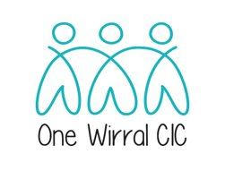
Practice Nurse PLT
Wednesday 1st March 1 – 4pm (lunch 12:30pm)
Conference Centre Floral Pavilion New Brighton
Development and Facilitation supported by One Wirral CIC
Time | Title | Speaker
1 – 1:10pm | Welcome, Introductions & housekeeping | Sue Smith  One Wirral
1:15 – 2:15pm | Managing Mental Health in practice & Service Update  Personal Resilience support  (Title TBC) | Victoria Lacey  Clinical Lead  Talking Together Wirral  Insight IAPT
2:15 – 2:45pm | How to help prevent burnout in today’s practice.  (Practical session) | Jackie Roycroft RGN  British Wheel of Yoga Practitioner
2:45 – 3:15pm | Coffee Break  Networking
3:20 – 3:40pm | Title TBC  C&M ICB Wirral Place update | Lorna Quigley  Associate Director Quality  C&M ICB Wirral
3:40 – 4pm | Military veterans – Update | Helen Hurst  PCN Lead Nurse HSW  Abigail Cowan  Mental Health Commissioner C&M ICB Wirral
4pm | Close

“The following pharmaceutical companies have sponsored this meeting in the form of stand space only:
Astra Zeneca, Leo Pharma, Orion, GSK, Chiesi, Abbott, Besins, Convatec &
Please note that the above pharmaceutical companies have not been involved in the agenda and/or content of the meeting”.

